**Topic:** To study interrupts

**Pre-requisite knowledge:** Basic motor control and its programming

**Components required:** Firebird V with 8051 adapter board

**Basic Concept:**

* **What are Interrupts?**

Interrupts interrupt the flow of program and cause it to branch to ISR(Interrupt Service Routine). These can be software/hardware and external/internal interrupts.

* **Working of Interrupts –** Whenever interrupts occur, the program completes executing its current instruction and branches to the vector location associated with that particular interrupt in memory.

Then it performs that service routine and returns back to main function after its completion.

It maintains the address by push and pop operation in stack. Whenever it branches to a service routine, it pushes current address into stack and after returning to main function, pop it back to continue from where it left.

* **Why interrupts are necessary?**

Interrupts are required to:

1. Perform many operations simultaneously
2. Avoid busy waiting or polling(stop unwanted processes)
3. To interface application that requires synchronization

* **8051 provides 5 vectored interrupts –**

1. http://nptel.ac.in/courses/Webcourse-contents/IIT-KANPUR/microcontrollers/micro/lecture9/images/lec9_1_clip_image002.gif
2. TF0
3. http://nptel.ac.in/courses/Webcourse-contents/IIT-KANPUR/microcontrollers/micro/lecture9/lec9_1_clip_image004.gif
4. TF1
5. RI/TI

Each of these interrupts can be individually enabled or disabled by 'setting' or 'clearing' the corresponding bit in the IE (Interrupt Enable Register) SFR. IE contains a global enable bit EA which enables/disables all interrupts at once.

**The schematic representation of the interrupts is as follows –**

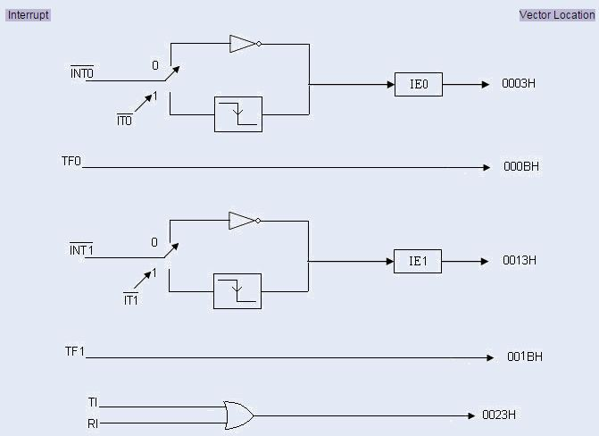**8051 Interrupt Details**

To learn more about these interrupts you can follow the link- <http://nptel.ac.in/courses/Webcourse-contents/IIT-KANPUR/microcontrollers/micro/ui/Course_home2_9.htm>

**Now let us learn how we can control position of the robot by using these interrupts –**

External hardware interrupts is used to control position. Robot’s left wheel position encoder is connected to Interrupt1 (INT1) pin of microcontroller. <Detailed knowledge of position encoder is covered in next section>

Every pulse from the encoder causes an interrupt to occur in the microcontroller. In ISR (interrupt service routine) of that interrupt an unsigned integer variable “left_shaft_count” is incremented and by comparing this count with the required/ desired count, position estimation is done.

* **The code for the above is given in the experiments folder.**

Hope you got the concept of interrupts.

**Exercise:** Write a program to buzz the buzzer after every two seconds using timer overflow interrupt. (Do NOT use the delay function)